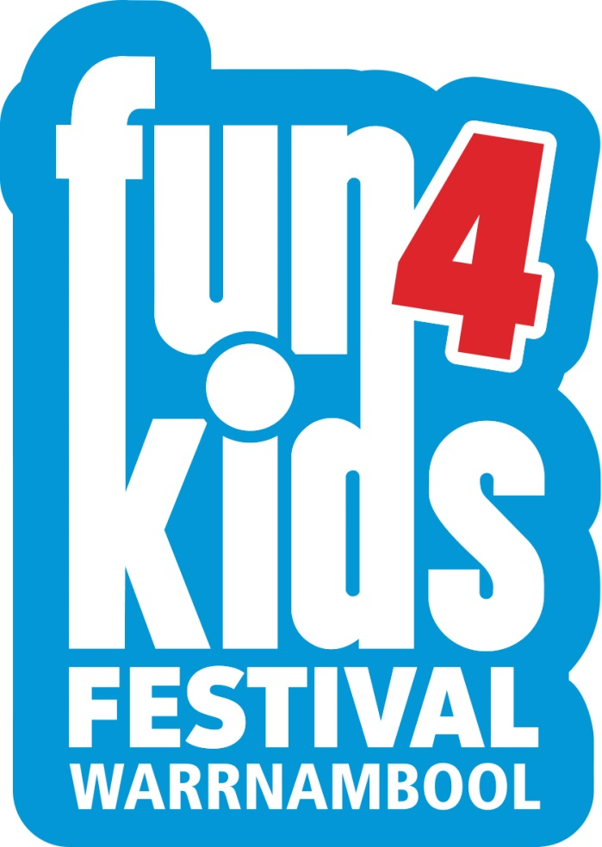

‘Expression of Interest’

CATERING SERVICES

FUN4KIDS FESTIVAL
Sunday 5th July – Saturday 9th July 2017

EXPRESSION OF INTEREST TO BE SUBMITTED BY
MONDAY 14th MAY, 2017

Dear Caterer,

Thank you for making contact with us in regard to Fun4Kids Festival 2017, which will be held from Wednesday 5th July to Sunday 9th July.

5 Days and Evenings of seriously good fun

The award winning Fun4Kids Festival is a not-for-profit event managed by the Warrnambool City Council and is recognised as ‘Australia’s Best Children’s Festival’. The festival attracts more than 14,000 parents and children annually.

Fun4Kids Festival aims to ignite imagination and spark creativity amongst kids and targets families with children up to 12 years old, from across Victoria. The festival is proud to be recognised as Australia’s Best Children’s Festival having recently won the award for Best Festival and Event at the 2015 Qantas Australian Tourism Awards and 2015 RACV Victorian Tourism Awards.

The fully indoor, 2 acre festival site offers children incredible interactive and educational zones, entertainment and activities, and a selection of the best children’s entertainment from Australia and around the world on two state-of-the-art performance stages.

A healthier twist

After trialling a healthier approach to our food offerings in previous years with great success, we have decided to continue with this approach for 2017 and beyond. Where possible, we encourage caterers to look at healthy alternatives (preservative free, artificial colour free, low fat, low sugar, high fibre etc.) to ensure we can provide tasty yet ‘good’ food options for families.

Catering opportunities

Each of the catering sites on offer will be situated in Festival Hall, which is located in the heart of the event site with high profile exposure, foot traffic and ample seating. Please see the site map and photos under ‘Site Locations’.

If you have an interest in catering in another area of the festival please detail this in your application.

The table provided (Fun4kids Festival 2017 catering sites) outlines the site criteria, and the reserve amount the Festival deems suitable for the site. Caterers can submit offers for a site(s) and the council will accept the provider deemed the most appropriate.

Please direct all enquires and your expression of interest submission to:

Glenn Scott
Site & Logistics Manager
Fun4Kids Festival
Telephone: 0407 676 300

Post: PO Box 198, Warrnambool Vic 3280
Email: gscott@warrnambool.vic.gov.au
Fax: Att: Glenn Scott, Fun4Kids Festival – (03) 5559 4900

Please Note – Applications subject to a hard copy of the signed Expression of Interest Form being received by Council within five calendar days of the submission closing.
Provision of catering services

Caterers must complete the Expression of Interest Form and attach any documents or other information requested. Your offer shall be exclusive of Goods and Services Tax (GST) and inclusive of incidentals for the supply of the specified services.

INFORMATION REQUIRED
Caterers should submit all information they consider relevant to allow assessment of their suitability for the contract. This shall include:

- Expression of Interest Form – Page 8
- Completion of Occupational Health & Safety Evaluation Form – Page 9
- Company details
- Proposed menus and prices
- Details of existing insurances including Public Liability, Workers Compensation
- A copy of current Certificate of Registration for the year of 2017 (under the Victorian Food Act 1984 or comparable Act if not Victorian based)
- Completion of Gas Safety Checklist – Page 23 of 25 ‘Code of Practice for the Safe Use of LP Gas at Public Events in Victoria’ (1 October 2009)
- Any other information that the applicant deems relevant

Please Note - Applicants may enter submissions for more than one catering outlet.

Services to be performed

CONTRACT TERM
Catering services will be required for the Fun4Kids Festival 2017, Wednesday 5th July to Sunday 9th July inclusive.

It is important to note that on site vans, cool rooms and site equipment will be required for set up prior to this contract term during site/marquee installation. Dates and times will be advised.

CONTRACTOR’S REPRESENTATIVE
The Caterer must appoint a competent person to be responsible for the day to day performance of the Services (“Contractor’s Representative”). The Caterer must notify the Site & Logistics Manager of the name of the Contractor’s Representative prior to the Commencement Date and must notify the Site & Logistics Manager immediately if a new Contractor’s Representative is appointed.

STATUTORY REQUIREMENTS
The Contractor must obey and must ensure that its employees, sub-contractors and agents obey any Acts, regulations or local laws included in any way applicable to the performance of the Services or this Contract including without limitation GST tax and any occupational health and safety legislation.

Insurance and indemnity

WORKERS’ COMPENSATION
The Contractor and any sub-contractor of the Contractor must, in respect of all of their employees, comply with the provisions of the Accident Compensation Act 1985 or any other Workers’ Compensation legislation in operation from time to time.

PUBLIC LIABILITY INSURANCE
The Contractor must be the holder of a current public liability policy of insurance (‘the Public Liability Policy”) providing coverage for an amount per event of at least $10,000,000.
The Public Liability Policy must cover such risks and be subject only to such conditions and exclusions as are approved by the Supervisor.

CERTIFICATE OF REGISTRATION
The Council will only approve registered food business and requires proof. The Contractor is required to submit a copy of their Certificate of Registration, (under the Victorian Food Act 1984 or comparable Act if not Victorian based) for the year 2016 from their local Councils (or from where the food vehicle is said to be permanently garaged).

PROVISION OF EVIDENCE
The Contractor must, on or before the Commencement Date, produce to the Site & Logistics Manager policies of insurance and receipts evidencing its compliance with worker’s compensation, public liability insurance and certificate of registration.

INDEMNITY
The Contractor must indemnify the Council and its Councillors and members of staff from and against all actions, claims, losses, damages, penalties or demands consequent upon, occasioned by or arising from its performance or purported performance of its obligations under this contract, including, without limitation, any acts or omissions of the Contractor’s agents and employees.

OCCUPATIONAL HEALTH AND SAFETY
Applicants must comply with Occupational Health and Safety legislation (OHS) when carrying out works for Council. To assist Council in evaluating the OHS ability of a contractor, they are required to submit the OHS Health and Safety Evaluation Form attached in the Appendix A.

Warrnambool City Council Health Officers will be conducting regular and unannounced food safety checks on every catering site throughout the Festival period. Caterers will need to ensure all monitoring records are kept in accordance to their Food Safety Program and that these documents are available and up to date for verification by Council’s Health Officers.

Applicants who do not submit the OHS Health and Safety Evaluation Form with their quotation may not be considered by Council.

SCHEDULE

SPECIFICATIONS

- Successful applicants will be required to operate each catering site for the 5 days of the festival between the hours of 10am – 7pm.

- Successful applicants are to design a menu selection that is reasonably priced and that will appeal to families. Applicants are required to supply a list of all proposed menu items and suggested retail prices as part of their submission. Where possible a menu range that includes “healthy” eating options is preferable.

- The menu must include at least one kid’s “meal deal” which includes a lunch meal and a beverage of 250ml, 375ml or 390ml

- Applicants are to include details of their experience in the provision of catering services of a similar scale to other events (include reference contact details)

- Successful applicants must have adequate resources and abilities to meet the demands for food and beverage required by festival patrons. It is expected approximately 14,000 patrons will pass through the venue over the 5 days averaging 1,770 per day. Please note that patrons are permitted to bring their own homemade food and beverages into the venue (no food purchased outside the venue is permitted).

- Successful applicants will be required to be fully set up by 5.00pm Friday 3 July 2017. Please provide an outline of all equipment; including dimensions that will be used as this may impact on construction timelines should large equipment need to be brought into the festival site. Please provide photos of all food vans, coffee carts etc. that are proposed to be used.

- Access to the site for set up and dismantle must be coordinated through the Site & Logistics Manager. Caterers must note that set up is subject to the site build schedule and catering facilities may be required to be installed early. The site build will begin on 21 June and the site will be cleared by 13 July, 2017.

- Fun4Kids will provide all tables and chairs for café areas and will be responsible for the cleanliness of these throughout the Festival. However the successful applicant will be required to keep their area well maintained and clean (normal food handling standards apply) throughout the duration of the Festival.

- Successful applicants will be required to comply with all applicable OH&S regulations including any occupational, health and safety policies and procedures as prescribed in the Fun4Kids Safety Plan. Successful applicants will be responsible for providing a safe environment for their staff employed on site, and in doing so must regularly complete safety risk assessments. Successful applicants are also required to induct staff in appropriate OH&S practice, and relevant conditions prescribed in the Fun4Kids Safety Plan. Applicants are required to fill in the OH&S Evaluation Form – Appendix A

- Successful applicants will be required to provide ample staff to service and maintain a smooth flow of customers through the Festival catering sites.

- Successful applicants will be responsible for the provision of suitable uniforms for all catering service staff to enable healthy and safe work practices and will be responsible for all laundering of uniforms

- Successful applicants will be required to give a list of staff names for accreditation (venue access) purposes. No staff or children of staff are allowed to use their catering accreditation to participate in the Festival activities or performances. If staff or children of staff wish to participate they will need to purchase a Festival ticket.

- Successful applicants are advised that there is to be no unauthorised advertising or marketing activities occurring within the catering areas and surrounds. Any such activities must be discussed with the Festival Director prior to the Festival. Similarly successful applicants must not display marketing or promotional materials (e.g. umbrellas or sandwich boards) without the prior consent of the Site & Logistics Manager.

- Successful applicants should be aware that some products may be regulated by sponsorship and/or supply agreements. Successful applicants will be required to abide by any such agreements.

- All carbonated and non-carbonated beverage items (including water) are to be purchased through the Festival’s preferred supplier. A comprehensive product list including pricing and contact details will be supplied prior to the event.

- In 2017 our preferred suppliers are SL Distributors and Sungold Milk. They are long term partners of the Festival through provision of in-kind goods and refrigeration for the catering stalls. The contact for product and ordering is: Paul Conheady, 0458 615 383. Their product range includes Schweppes, Nestle, confectionary, pop tops, snacks, bottled water, etc. and also a range of cleaning products.

- Other products (esp. dairy) may also be regulated by a sponsorship agreement. Successful applicants will be advised of any such agreements. Successful applicants will be notified of any additional sponsorship and/or supply agreements upon execution of the catering agreement.

- At the time of the Expression of Interest being opened, the suppliers relevant to the 2016 catering sites are SL Distributors and Sungold Milk. Further information about their supply of product to the festival, and specifically the catering sites, can be directed to Glenn Scott.

- Successful applicants will be required to be a registered food business and should fully comply with the Food Act 1984.

- Successful applicants are required to have signage/menu boards that clearly list menu items and prices.

- Applicants should be aware that all electrical equipment must be tested and tagged in compliance with AS 3760 for a current 3 month period. Leads and appliances will be inspected for a current test tag before access to power is given. No testing or tagging will be carried out on-site and must be finalised prior to set up at the event site.

- Successful applicants will be required to indicate power requirements to Management prior to the commencement of the event.

- Successful applicants must comply with fire regulations and provide a fire extinguisher at their site.

- Successful applicants are advised that after hours security will be provided for surveillance of the Fun4Kids village. Successful applicants wishing to engage a security company or personnel for after hour’s security of their catering equipment must obtain written approval from management. Successful applicants are advised that they must have adequate property and liability insurance to cover any losses during the event.

- Successful applicants will be required to comply with the new ‘Code of Practice for the Safe Use of LP Gas at Public Events in Victoria’ (1 October 2009).

- Fun4Kids reserves the right to relocate catering sites due to logistics and site limitations

CARBON FRIENDLY EVENT

Fun4Kids is an environmentally friendly event and has previously achieved Best Practice (Gold) status in association with Victoria’s Waste Wise initiative.

In 2017 the festival will once again try to deliver an event that has good recycling and waste reduction systems including:

- Explaining the benefits of sustainable waste management to patrons
- Avoiding waste and litter where possible
- Using reusable packaging in preference to disposable
- Controlling packaging so that waste diversion from landfill is maximised
- Giving preference to recyclable and recycled content packaging

To maintain the high standard set in previous Festivals it is imperative we receive cooperation from caterers and stall holders. Once caterers are confirmed Fun4Kids Festival will need to:

- obtain a verbal commitment from all stall holders
- develop a recycling and monitoring system for all stall holder waste
- see a substantial effort from stall holders to eliminate disposable packaging items
- ensure stall holders use all food packaging with recycled content with a written commitment

ADDITIONAL CATERING

Applicants are informed that additional catering will take place within the Fun4Kids venue. The details of the additional catering are as follows:

- Confectionery sales will be controlled by the Fun4Kids Festival. There are to be no sales of confectionery items from the catering outlets in this quotation.
- Several sponsors may take up the opportunity to have a stall in the food court.

ONSITE INFORMATION

Festival site maps will be placed throughout the venue which will show all food and beverage outlets within the Fun4Kids venue.

SITE LOCATIONS TABLE
Catering sites available at the 2017 event Wednesday 5th July to Sunday 9th July.are as follows:

PLEASE NOTE - All food types outlined are only a guide; the Festival welcomes other potential offerings.

# | LOCATION | SIZE | STORAGE  AVAILABLE | HOURS OF  OPERATION | RESERVE $
1 | Festival Hall | 3m X 3m | Yes | 10am-7pm | $2,000
2 | Festival Hall | 3m X 3m | Yes | 10am-7pm | $2,000
4 | Festival Hall | 3m X 3m | Yes | 10am-7pm | $2,000
5 | Festival Hall | 3m X 4.5m | Yes | 10am-7pm | $3,000
3 | Festival Hall | 3m X 3 m | Yes | 10am-7pm | $2,000
6 | Festival Hall | 3m X 3m | Yes | 10am-7pm | $2,000
7 | Festival Hall | 3m X 3m | Yes | 10am-7pm | $2,000
8 | Pirate Cove | 3m X 3m | Yes | 10am-5pm | $1,500

NB - Please advise your cool room requirements on the Expression of Interest Form – Page 8.

Please note: Other food types will be considered, and caterers should not be limited by food types which have been offered at previous events. Festival management reserve the right to determine the best fit & mix of sites per event requirements.

EXPRESSION OF INTEREST FORM

Provision of Catering Services - Fun4Kids Festival 2017

Preferred Catering Site Number…………………………….

Proposed Offering:………………………………………………………………………………………

…………………………………………………………………………………………………………….

$.............................................................................…………………………….excluding GST
(In words)

$ …………………………………………………………………………………….excluding GST
(In figures)

Do you require cool room space? Yes No

If so, how much space do you require? ...................................................................................

Contractors Name..................................................................................

ABN Number…………………………………………………………………

Address.................................................................................................

Phone……………..………………………………………………………….

Mobile Phone...………………………………………………………………

Signature...............................................................................................

Date.......................................................................................................

This form must be submitted with your detailed Expression of Interest including :

- Proposed menus and prices;

- Details of relevant and similar scale experience including reference contact details;

- Details of existing insurances including Public Liability, Workers Compensation;

- A copy of current Certificate of Registration for the year of 2017 (under the Victorian Food Act 1984 or comparable Act if not Victorian based);

- Be registered with “Streatrader”

- Address all requirements/criteria as required;

- Send to Glenn Scott, Site & Logistics Manager, PO Box 198 Warrnambool VIC 3280 or email gscott@warrnambool.vic.gov.au or fax: 03 5559 4900

APPENDICIES

APPENDIX A – OCCUPATIONAL HEALTH AND SAFETY EVALUATION FORM

This form is to be completed and submitted with the tender. Please include copies of policies, extracts from log books, sample reports and completed checklists to demonstrate that your organisation has an appropriate health and safety management system in place. It is your responsibility to provide sufficient information to satisfy this requirement. Contractors will be required to verify their responses to questions by providing evidence of their ability and capacity on relevant matters.

YES NO N/A

Do you have a Health and Safety Policy in place? Attach copy.

Do you have…?
- An OH&S Management Systems Manual?
- Safe Operating Procedures or Instructions?
- An accredited OH &S Management System?
(Attach summary of procedures or contents page of Manual)

Have your employees been provided with health and safety training?
Do you periodically conduct audits of your work practices and
Work places?

Do you perform regular preventative maintenance on equipment?
That you intend to use as part of the contract?

What chemicals do you intend to use as part of the contract?
Attach an extract from your register of chemicals, if applicable.

Do you have material safety data sheets for each chemical?

Will you be operating plant that require certificates
Of competency? If yes, provide details.

Do you have…?
- A Workplace Health and Safety Committee?
- A Health and Safety Representative?

Do you have procedures for accident investigation and reporting?
If yes, provide details or sample report.

Have you ever been convicted of an OH&S offence?
If yes, provide details.

Certification

The information provided in this questionnaire is an accurate summary of our occupational health and safety management systems.

Contractors Name: __________________________________________________

Signed: __________________________ Name: ___________________________

Position:_____________________________________ Date:_________________

*** Please Note – Site Plans are subject to change without notification ***
Food Vendors adjacent to Festival Hall

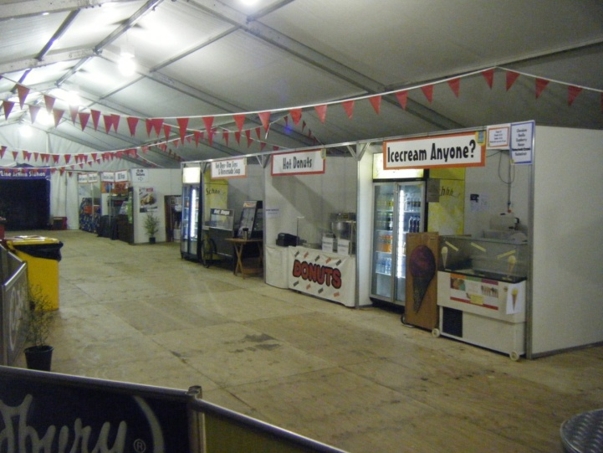
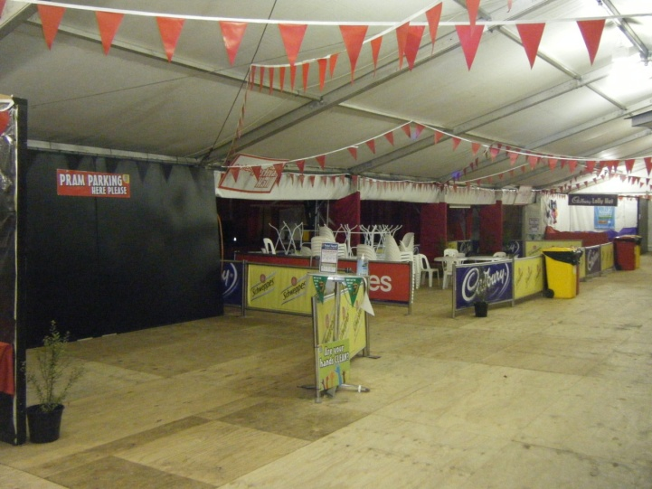
CATERING SITE – PHOTOS

